|  |  |  |
| --- | --- | --- |
|  |  | **Information Sciences and Technologies**  **Golisano College of Computing and Information Sciences** |

hw 01a: Mac Survival Skills

# Overview

Experienced PC users will find the Mac different. This exercise is an overview of how Macs work and acquaint the student with the environment. This course is entirely Mac-based so Mac skills are required. Supply answers to the questions in this document. When completed, upload it to the dropbox.

# Activities

1. Locate the **power button** to turn the lab Mac on and off. Turn it on if necessary.
2. Locate the **apple menu.** List 3 choices from this menu.
3. About This Mac
4. System Preferences
5. App Store
6. Click on the **Safari** icon in the **Dock** at the bottom of the screen to launch it. (Note: One can always switch back to an already running application by clicking on its Dock icon.) How does the dock tell you an application is running?

There’s a little indicator in the form of a dot that notices the user that an application is running.

1. Which **colored button** in Safari will minimize a window? Make it so! Where does the window go? Which colored button minimizes?

Yellow Button minimizes Windows, which then proceeds to go to the dock.

1. Launch the Adobe Photoshop application the old fashioned way by double-clicking on it. To do this, navigate to the **Applications** **directory** in the **Finder**. Start by double-clicking the hard drive icon on the **Desktop** to open a new window.
2. Navigate to Photoshop inside of the **Applications** folder. Choose **View->as Columns** under the **View** menu to make the window appear similar to the screenshot below.

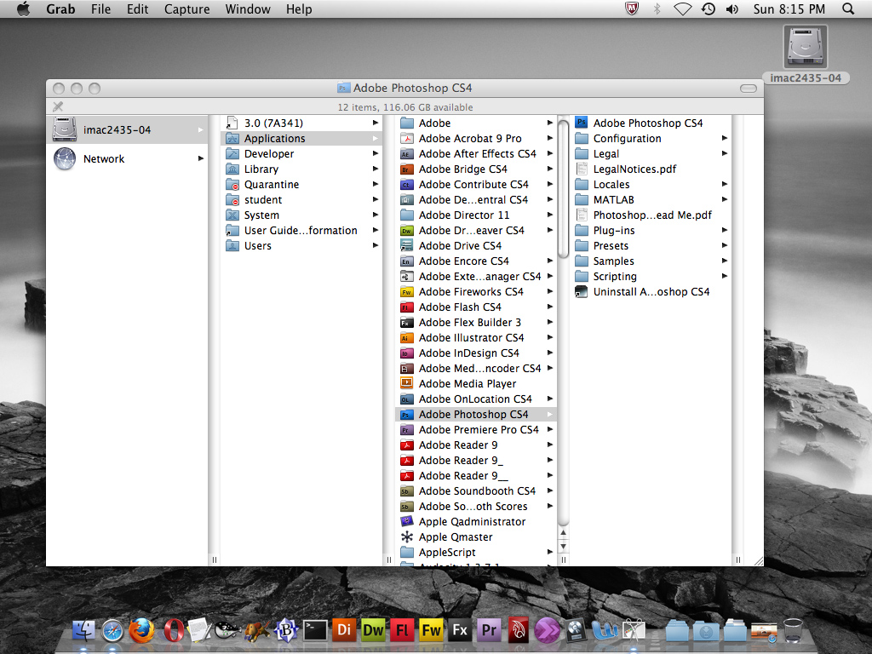

1. Now double-click on **Adobe Photoshop** to launch it.
2. Another way to launch recently used applications and documents is to access **Recent Items** under the apple menu. Go ahead and launch an application that appears there.
3. The most popular and easy way to launch applications on OS X is to use **Spotlight** to search for it. Spotlight can be accessed by clicking on the magnifying glass in the far-right side of the menu bar at the top of every application. To run the **Digital Color Meter** using Spotlight, typing in "digi" should bring it up.
4. A quick way of bringing up Spotlight is to use a keyboard shortcut. On the Mac, the **Command Key** is used instead of the control key used in the PC (Windows) environment. The command key is the cloverleaf (** or ⌘ )**, and/or the word "command" on it. Try out the Spotlight shortcut by using **⌘-spacebar** to launch the **Activity Monitor** Application.
5. Many applications may be open but are not needed. A convenient way to quit every application except Safari uses the key combination/sequence **⌘-tab** to switch between running applications, and then use **⌘-q** to quit them. Do this for every application except Safari and the Finder
6. Close remaining Finder windows by clicking the red circle in the upper-left corner of each window.
7. Click on the desktop to make the Finder the active application. Now look under the **File** menu and choose **New Folder**. The folder should appear on the desktop. Select it and rename it to **images**.
8. Remember hiding that Safari window way back when? It should still be minimized in the Dock - go ahead and click on it to bring Safari and that window back in focus.
9. Re-size the Safari window so that it fills about 75% of the monitor so that the images folder is visible. To do this, click the green zoom button to do some re-sizing. This likely may require use of the re-size box in the lower-right corner of the window as well.
10. Now to download and work with files. Navigate to **images.google.com** (it’s not necessary to type in the http://) and do an image search for "RIT."
11. Choose an image and click on it to navigate to the web page on which it originated. Now try downloading it. The easy way is by **clicking and holding on the image**, and dragging it to the desktop. The icon will appear on the desktop wherever the mouse button is released.
12. Another way to download an image (or any file) is to **right-click** on it and manually navigate to the directory where the file is to be saved.

Apple's implementation of the three-button mouse is a little odd. Using the shortcut of **control-click** or **ctrl-click** (NOT **⌘**-click) is easier to do. In fact, right-clicking gives properties in the same way as does a PC.

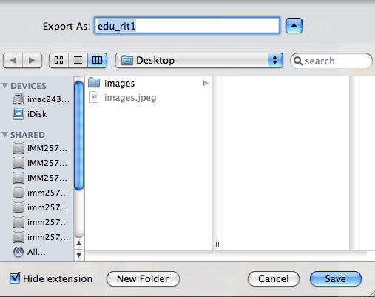

**Right-click (ctrl-click)** on the image to obtain a pop-up menu with choices like **Save Image As...** or **Download Linked File ...** After choosing an appropriate one, there will be a dialog box similar to the one shown here:

To make the Dialog box appear as this one does, select the **Column View** icon, and click on the **disclosure triangle** on the right. Go ahead and save the file to an **images** folder.

1. Double-click on one of these images in the Finder. OS X will likely automatically launch the Preview application to view the file.
2. Quit Preview.
3. What if the image had to be edited in Adobe Photoshop? One way to make that happen is to **right-click** on the image, select **Open With** from the popup menu, then choose Adobe Photoshop from the list of applications. Try it now, then quit Photoshop.
4. Delete the first image downloaded (not the one in the folder) by dragging it to the **trash**. How can you tell that there are items in the Trash Can?

The Trash Icon in the dock shows pieces of garbage inside the trashcan graphic

1. Go ahead and **empty the trash**. Write down at least two ways to do so.

1. Delete all Items inside the Trash after opening it on Finder.
2. Right Clicking the Trash Icon and selecting Empty Thrash
3. Duplicate the **images** folder by selecting the folder and locating the Finder **Duplicate** menu item.
4. Another way to duplicate items in the Finder (and in many other applications) is to **option-drag** an item. Try it.
5. Use **File->Get Info** to get information about the **images** folder. Note that in this window items can be renamed.

# Submission

When all questions have been completed and placed in the boxed outlines, save it as <lastname><firstinitial>-hw01a.docx (without the angle brackets, e.g.**leonej-hw01a.docx**). Then upload it to the drop box on or before the due date. Late submissions will receive a 10% deduction per each day late.

# Try to do steps 27 - 29 prior to the next class meeting. They must be done before the due date for dropbox 01a

1. Login to **myCourses.rit.edu**
2. Click on the **Discussions** tab and find the thread called **introductions**. Go ahead and post a quick introduction for all to see. Give your name (what you like to be called), major and year, hometown, and three favorite bands or movies.

Also tell us what is exciting about IT in general (social networking, games, programming, web development, video, animation, web applications, mobile development, databases, security, servers, spidering web sites, hacking, ???)

1. Click the **Logout** button in myCourses to end the session and preserve privacy.

|  |  |  |
| --- | --- | --- |
| **HW 01a: Mac Survival Skills** |  |  |
|  |  |  |
| **Category** | **Weight** | **Score** |
| Apple menu: 3 choices listed | 2 | 0 |
| Indication by Dock an app is running | 1 | 0 |
| Which colored button minimizes | 1 | 0 |
| How to tell there are items in the Trash Can? | 2 | 0 |
| Two ways to empty Trash Can | 1 | 0 |
| Self-introduction in "Introduce Yourself" discussion | 3 | 0 |
| **TOTAL:** | **10** | **0** |